1. ACCOUNT CREATION

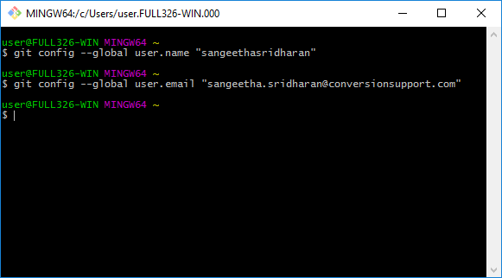

2. TO INITIALIZE GIT REPOSITARY IN WINDOWS

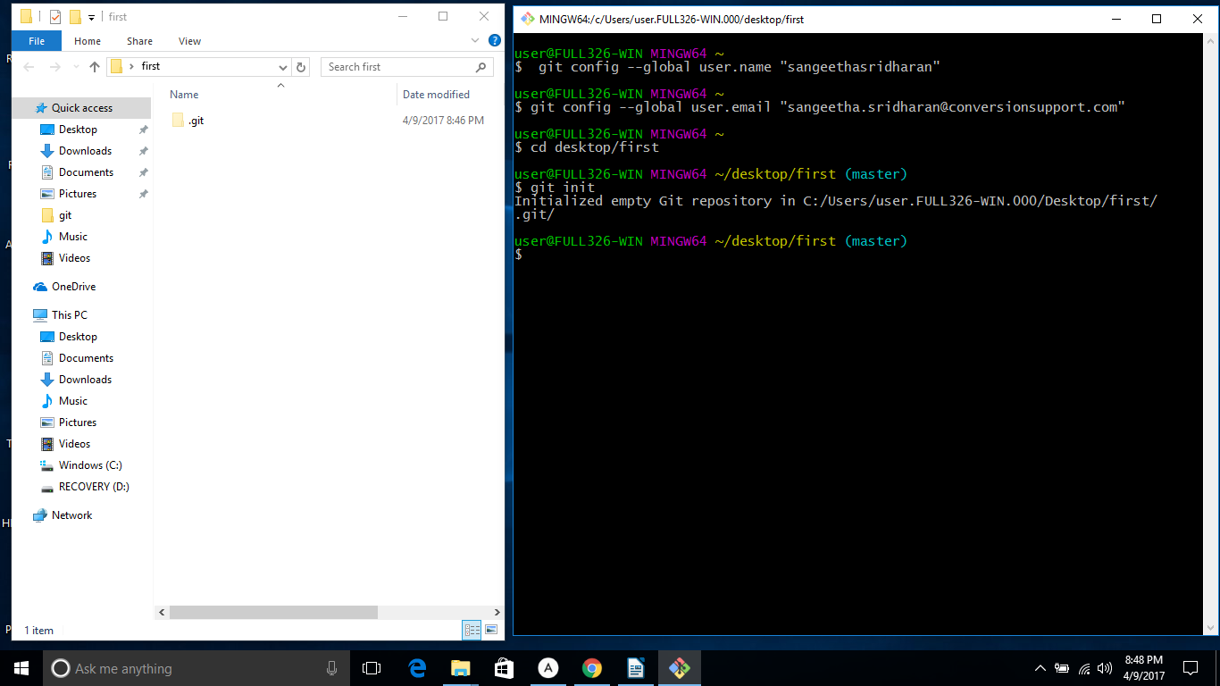

3. TO CREATE A NEW FILES/FOLDER

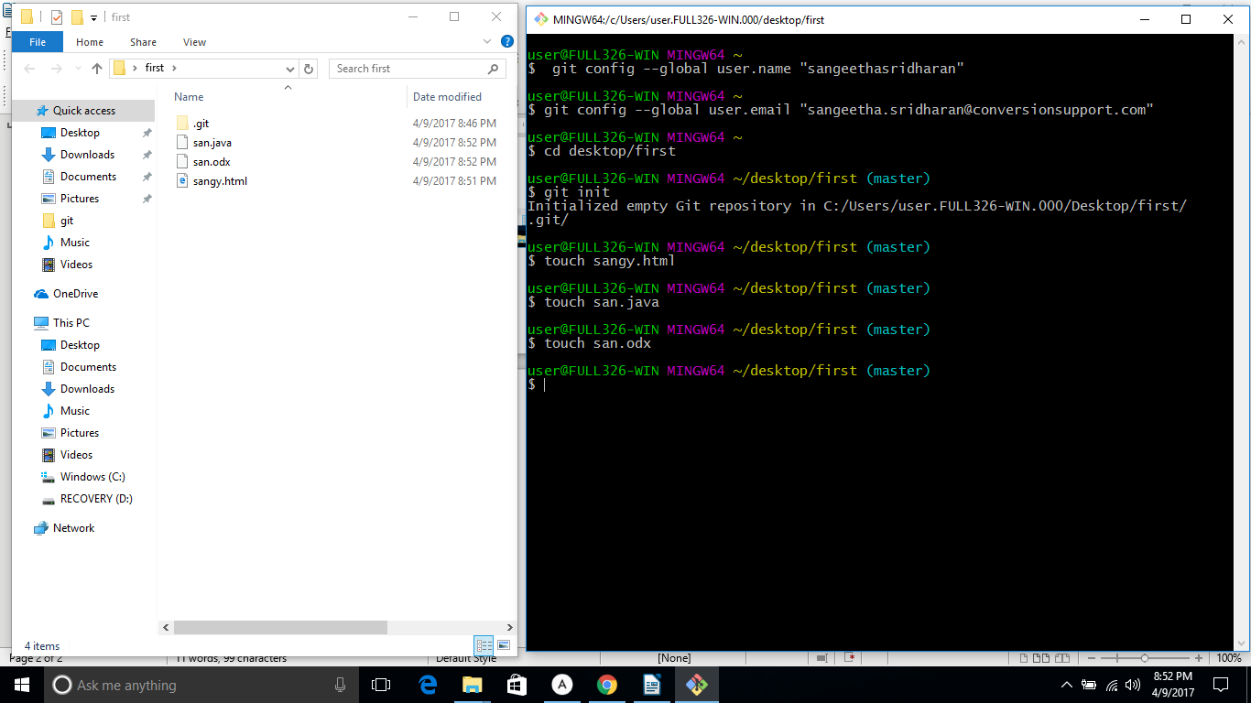
4. TO SEE STATUS
4.1 BEFORE TRACKING

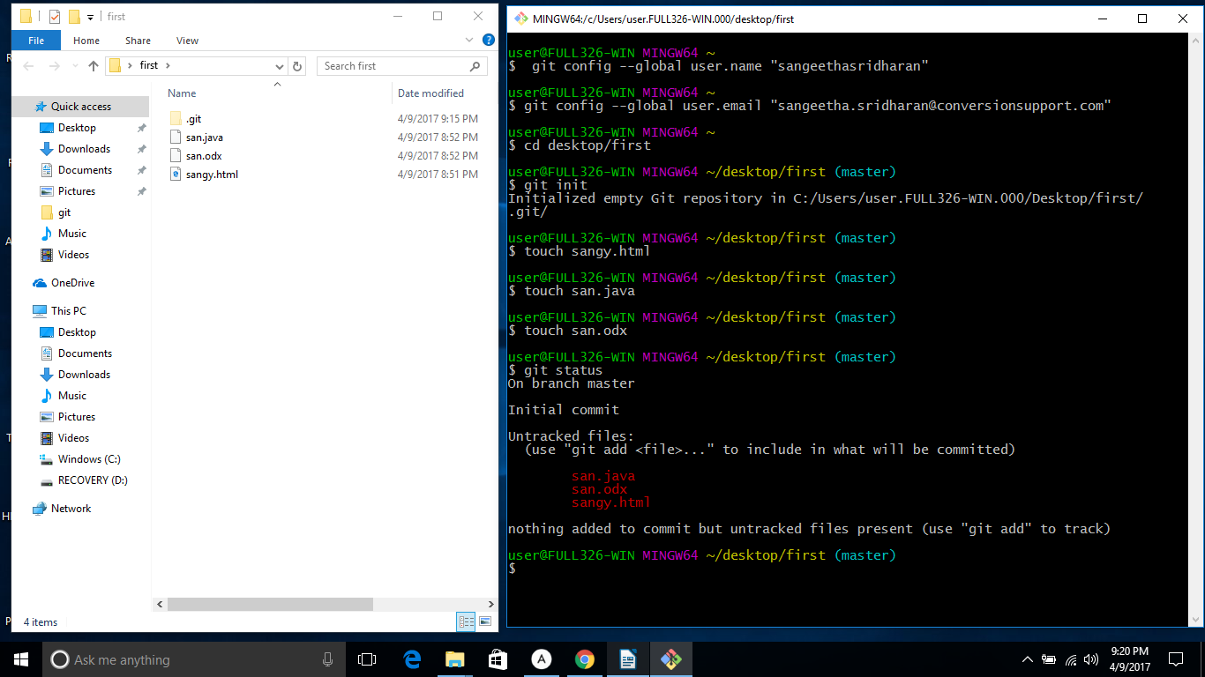
4.2 TO ADD ALL FILES /FOLDERS

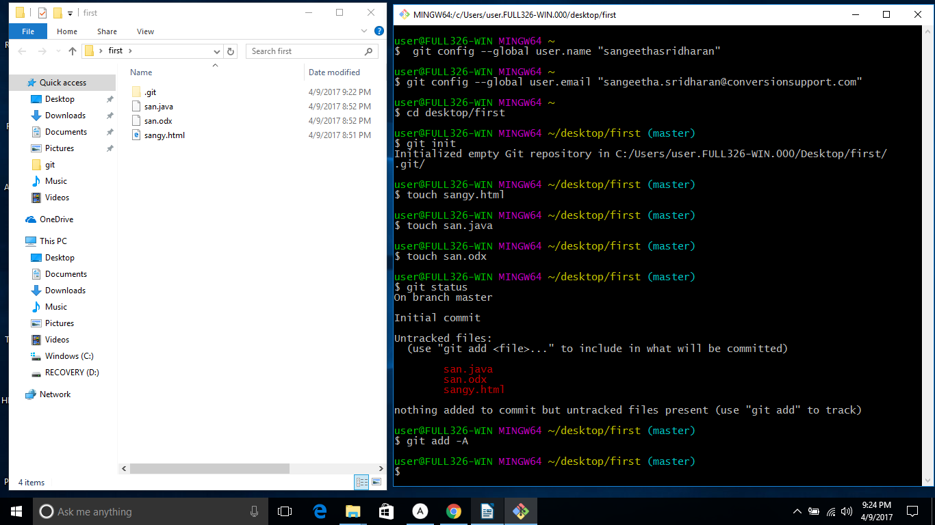
4.3 AFTER TRACKING and IT WILL ALSO GET STAGED TO COMMIT

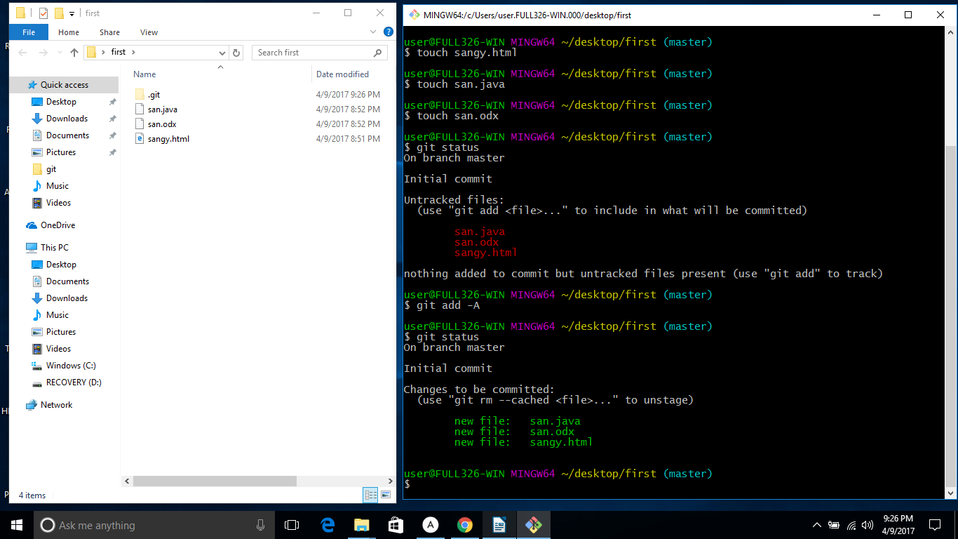

5. IF ANY CHANGES MADE THEN AGAIN WE SHOULD STAGE IT

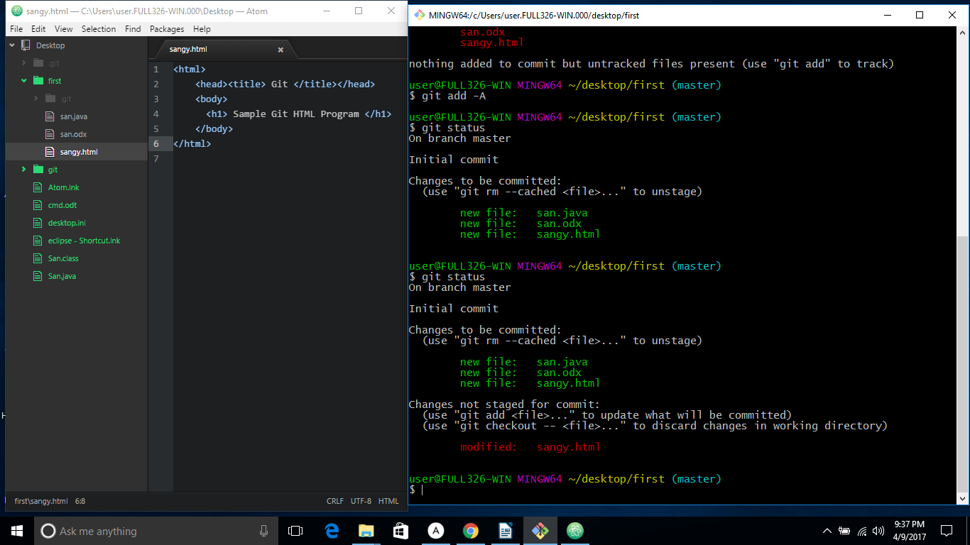
6. GIT IGNORE (USED TO AVOID STAGING)
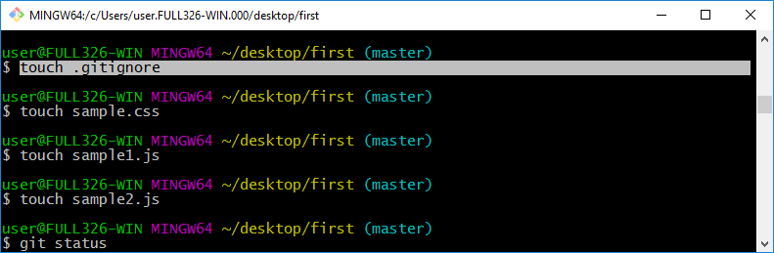
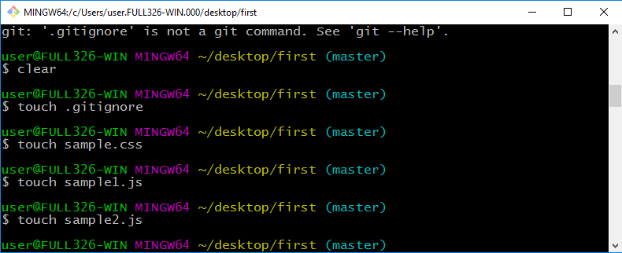

IT WILL IGNORE THE FILES THAT WE ADDED INSIDE THE "GIT IGNORE" FOLDER TO STAGE

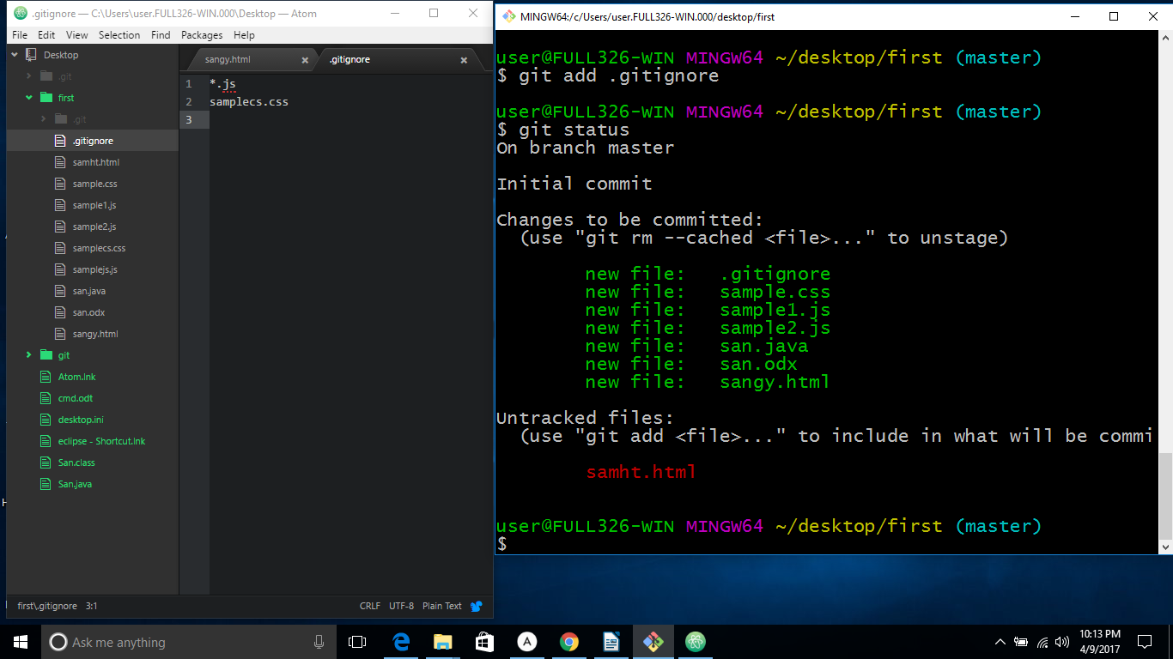

7. COMMIT

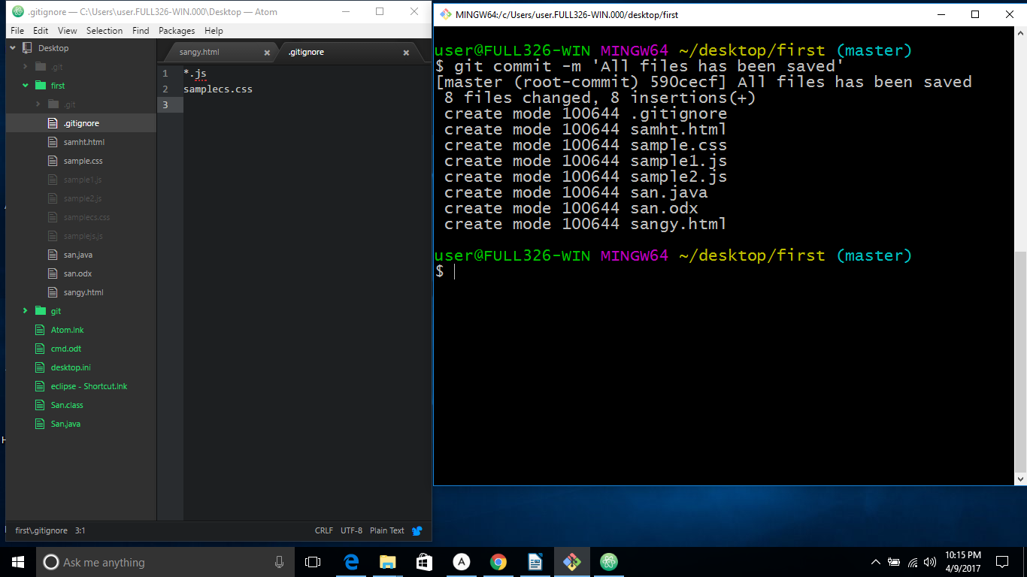
BRANCHING AND MERGING

1. TO CREATE BRANCHING

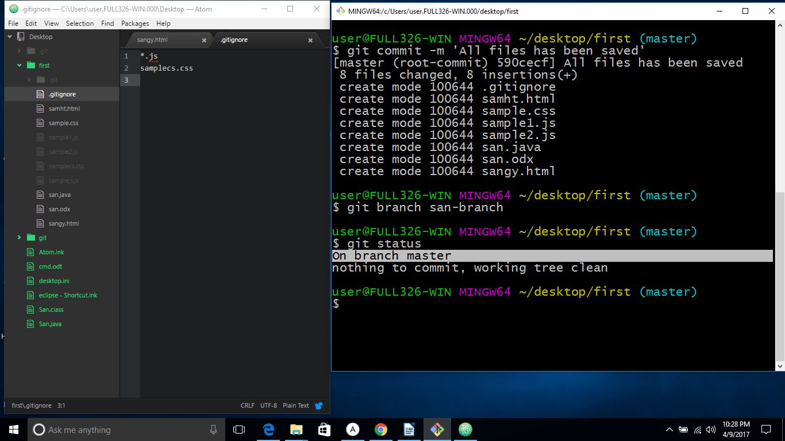
CHECKOUT( USED TO CHANGE THE MASTER )
-> SWITCHED TO BRANCH

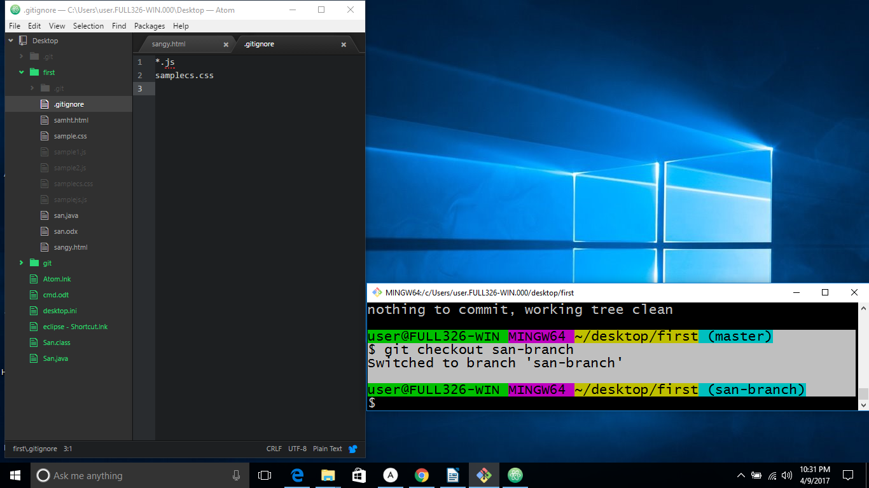
IN BRANCH BEFORE MERGING

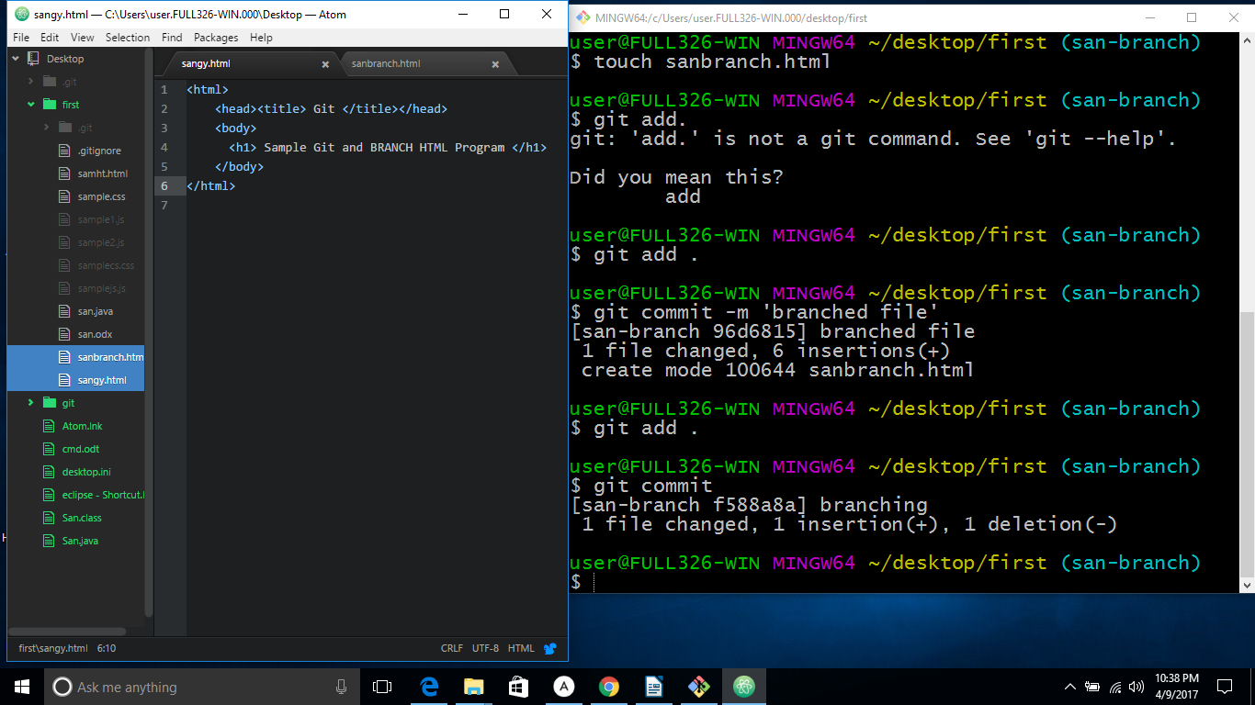
IN MASTER

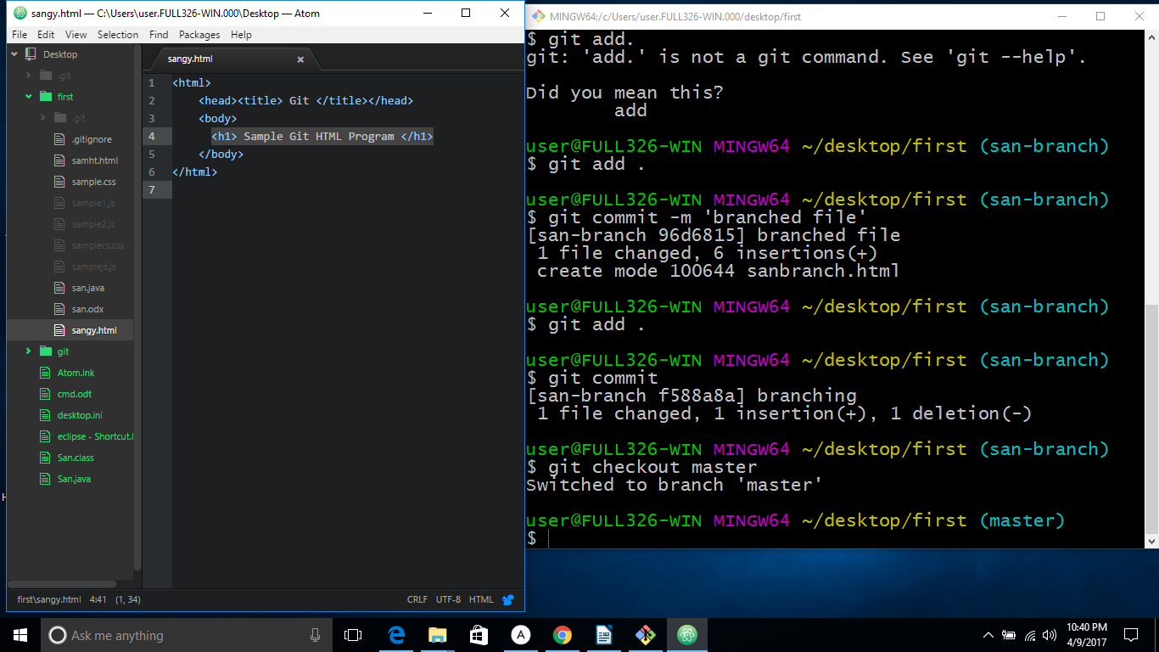
AFTER MERGING

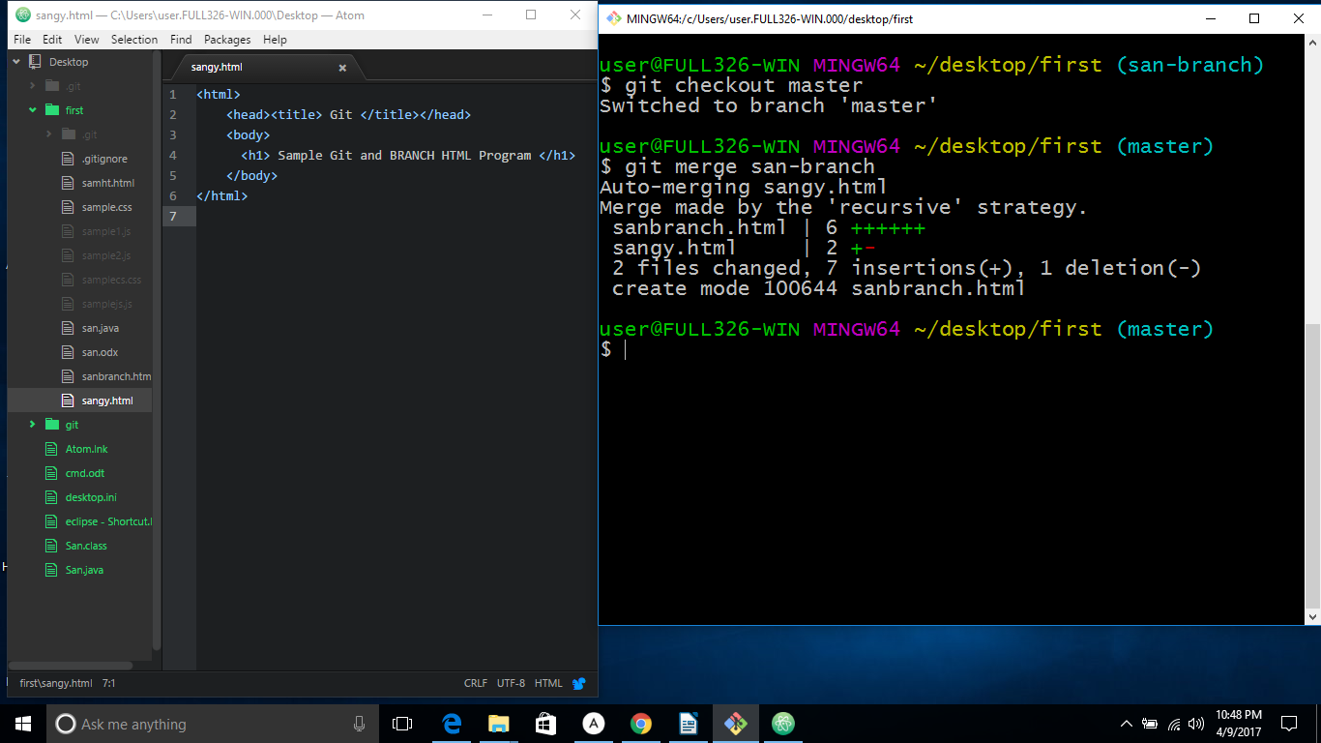

GIT HUB

1. CREATE ACCOUNT IN "github.com"

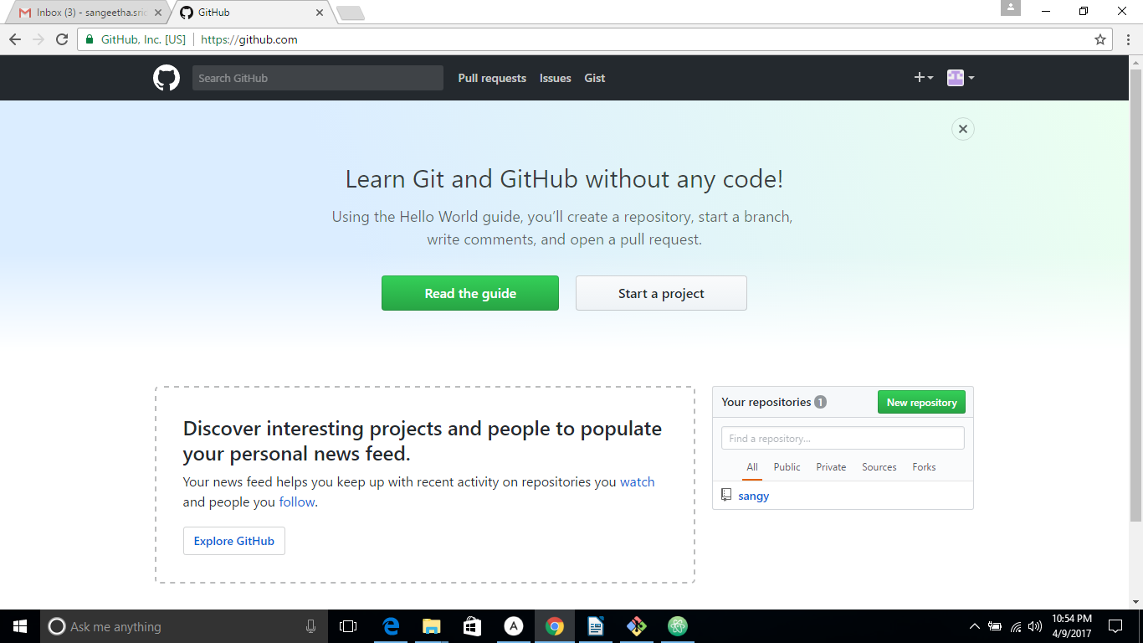

2. TO REDIRECT TO THE REMOTE ORIGIN

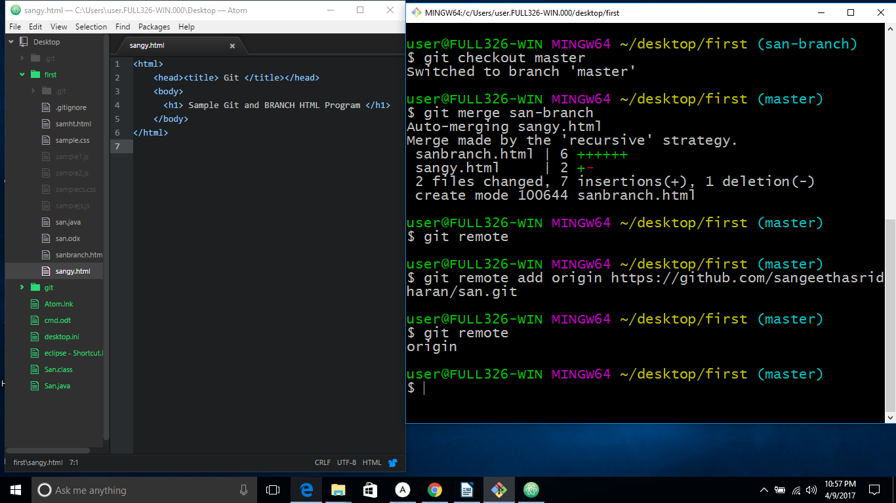
3. TO PUSH IT IN REMOTE

IT WILL CHECK FOR AUTHENTICATION
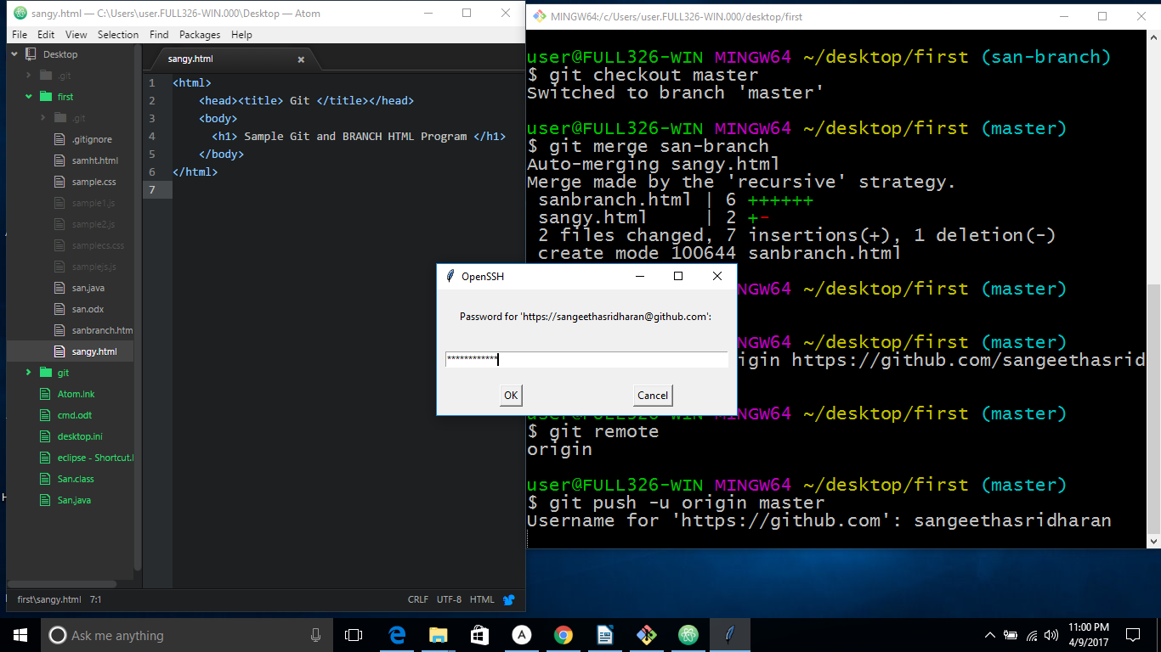

TO CLONE

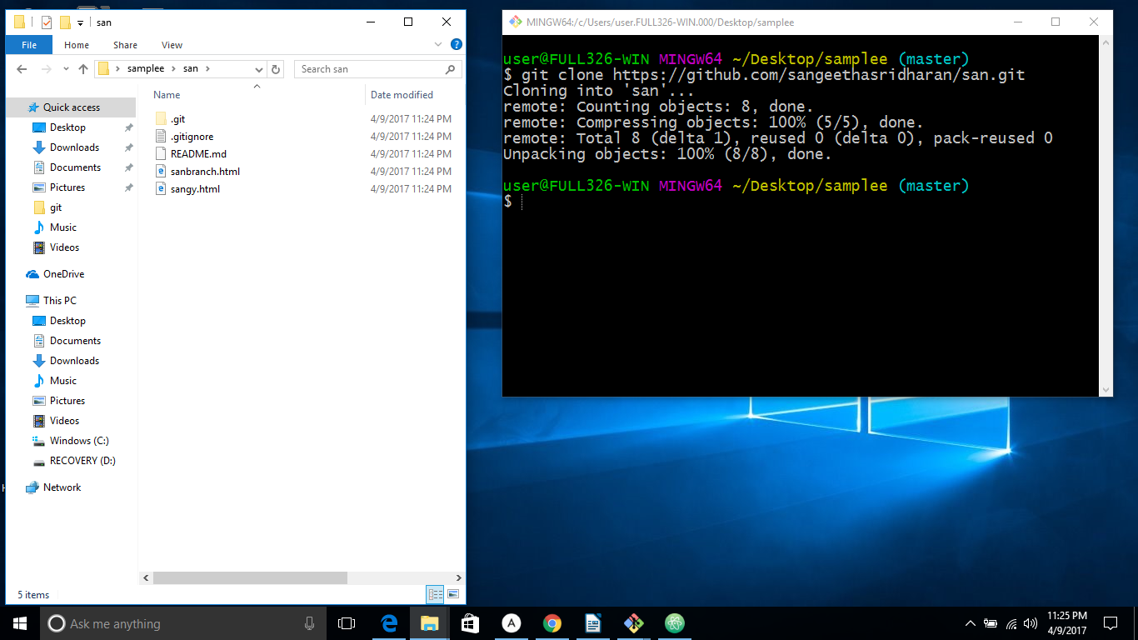
Note : We can push window repositary to remote ,once we had done with clone option. And we need to push everything in window folder which is cloned , then only we can able to push it in remote repositary.

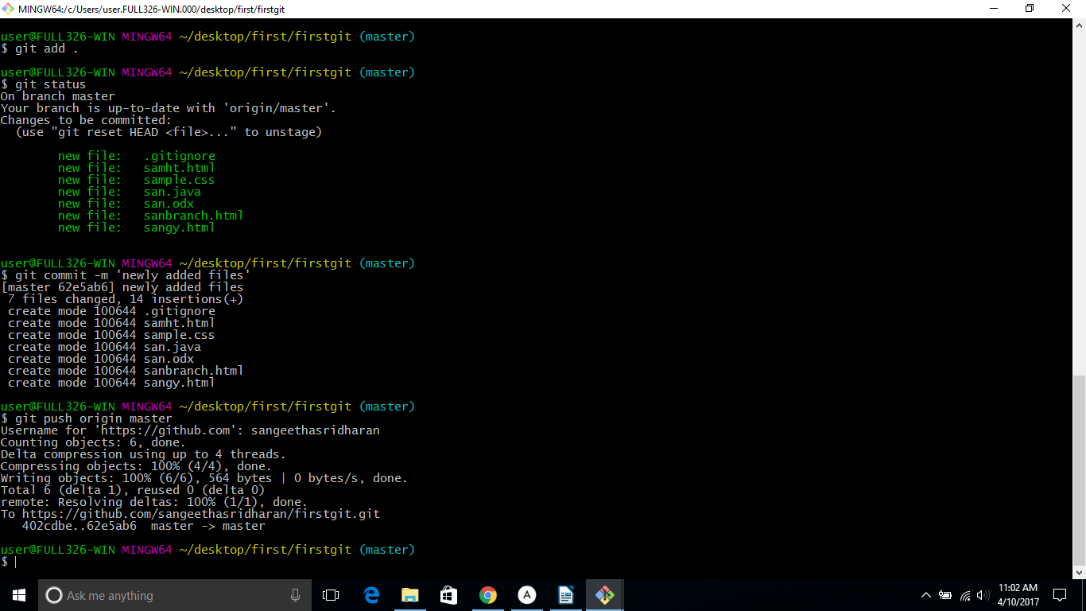

1. Git remote add <some name> <url>
2. git pull <some name> <branch name>

